

SUMMER EXAMINATIONS 2012

Wednesday, 16th May 2012, 14.30 – 16.30 p.m.

KSDEM_8_Y2

Courses: Bachelor of Science (Hons) in Software Development

Year: Two

Subject: Software Development

Time Allowed: 2 Hours

Instructions: 1. Attempt any THREE (3) of the following FIVE (5)
questions.

2. Questions do not carry equal marks

3. Start each question on a new page.

4. Write the question number at the top of each page.

5. Circle the numbers of the questions you answer at the front of your answer book.

Additional Attachments Exam Materials to accompany this paper:

- None

Internal Examiner(s) External Examiner(s)
Mr. Brendan Watson Dr. Cornelia Connolly
Dr. Brian Nolan
Q. 1
Read the following information and answer the questions below:

Fire officers are stationed in fire stations. Fire officers work in a team and each team is managed by a supervisor. Incidents are reported by members of the public and the incidents are investigated by the teams. The details stored on fire officers are name, address and the details stored on fire station are district name, phone number. The details stored on teams are name, date formed and the details stored on supervisors are name and grade. The details stored on incidents are address, type, date reported and the details stored on members of the public are name, phone number.

- Draw the UML class diagram which models the information given above and specify name and multiplicity of each association and specify suitable types for all the attributes. Explain how an association models the potential for links to occur. (14 marks)

- On your UML class diagram specify that all the attributes of the fire officer class are private. Provide suitable assessor methods for all the attributes of the fire officer class (get and set methods) and specify the signature of each of the assessor methods you added.
(4 marks)

- On your UML class diagram specify the following using UML

- All the address attributes as have a multiplicity of three.
- The date formed attribute of the team class may not be changed after the object is initialized.
- Add an attribute called status to the incident class and specify a default value of Open.
- Add an attribute called grades held to the supervisor class and specify it so that it can hold a grade history for the supervisor.
(8 marks)

- Draw an instance diagram using the information below and your UML class diagram. Make up any other sample data you need for attribute values.
Fred Kelly and Harry Shine are fire officers stationed in the Limerick district fire station on the house fire team. The house fire team is supervised by Sid Shine. A house fire incident in Moylish was reported by Mark Black on 1/2/12 and was investigated by the house fire team.
(8 marks)

(Total 34 Marks)

Q. 2
- Explain what an actor is. Answer the following and explain your answer:
Could the same person fulfil the role of many actors?
Can the role of a given actor be fulfilled by many people?
(9 marks)

- Document the following use case which you participate in. You may assume you are starting out with your web browser displaying the LIT student portal.
- Access Moodle to save a software development Microsoft Word practical to the Windows desktop.

Document your use case using the following headings: Use Case Name, Participating Actor, Entry Conditions, Flow of Events, and Exit Conditions. Draw the use case diagram showing the above use case and show the system boundary on your diagram.
(11 marks)

- Explain what a communication relationship between an actor and a use case models. Give an example use case diagram showing both bi-directional and uni-directional communication relationships.
(7 marks)

- Document a realistic scenario for the use case you developed in answering question 2b) using the following headings: Scenario name, Participating actor instance, Entry conditions, Flow of events and Exit conditions.
(6 marks)

(Total 33 Marks)

Q. 3
- Give a definition of inheritance and explain three points about inheritance..
(10 marks)

- Sketch Figure 1 in your answer book and do the following:
- Label the base class and label all of the superclasses and subclasses.
- Label all of the associations and the generalisation symbols.
- Add subclasses called ConsultantDoctor and JuniorDoctor. Objects of these classes are just like Doctors but in addition the ConsultantDoctor has an attribute called speciality of type string and a method leadTeam with signature of one argument named aTeam which is of type Team and the JuniorDoctor has an attribute called hourlyRate of type integer.
- Add an abstract method treatPatient to the Doctor class which has one argument called aPatient of type Integer and returns a boolean and override this method in the JuniorDoctor and ConsultantDoctor classes.

(15 marks)

- List all the features of the ConsultantDoctor and Public Patient classes. Is there an association relationship between Ward and Public Patient classes? If so explain optional and mandatory in relation to this association.

. (8 marks)

(Total 33 Marks)
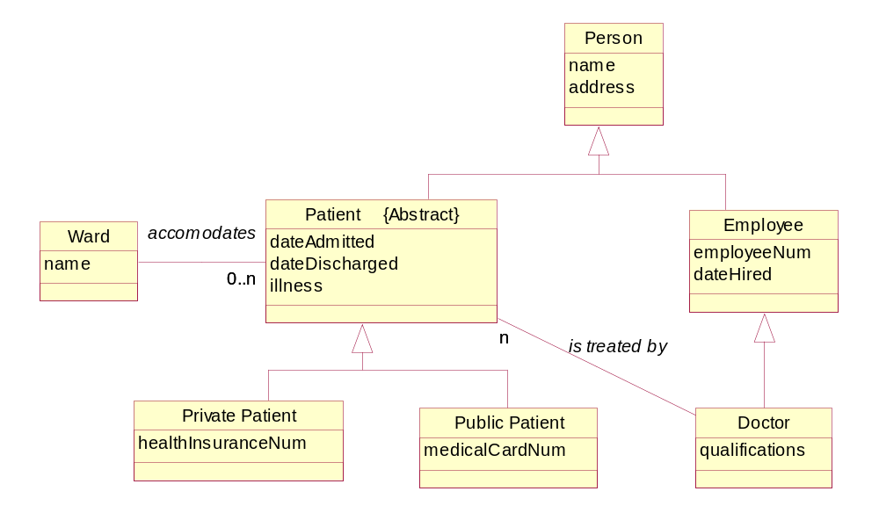
Figure 1
Q. 4
- Explain functional and structural testing. Explain how functional and structural testing apply to integration testing.
(6 marks)

- Develop a control flowgraph for the pseudo code sample below and determine the complexity. What would you conclude about a piece of code that has been tested so that Co = 90% and C1 = 60%. Has complete coverage been achieved and would you recommend further testing?
(12 marks)

- Develop a branch and block table for the Pseudo code sample below.
(15 marks)
(Total 33 Marks)

// Below are a few Psuedo code messages to manipulate a // PieEater object.
//Line Reference Nos.
initialise () // 1
2 timesRepeat // 2
{ // 3
PieEater_B turn(right) // 4
If myGrid clearAhead(PieEater_B) = true // 5
{ // 6
PieEater_B walk(MyGrid) // 7
} // 8
} // 9
If myGrid pieInSight (PieEater_B) = true // 10
{ // 11
PieEater_B eatPie(MyGrid) // 12
} // 13
reportStatus() // 14

Pseudo Code Sample

Q. 5
- Explain the waterfall lifecycle model and draw a diagram of it. Describe five disadvantages of the waterfall lifecycle model.
(12 marks)

b) Software development is now seen as team problem solving. Explain each of the four problem solving phases. Are the phases marked by completion of all activities for that phase? Explain your answer.
(12 marks)

c) Building models is very important in software engineering. Explain what a model is and explain three reasons why we build models. (9 marks)

(Total 33 Marks)

